e-Grips Website Updates (01.14.12)

FIRST DIBS PAGE: The last set posted, November 2010, was Limestone Rails. We need to have this page updated with all of the sets since:

January 2012: Caterpillar Shallows (11S4)
December 2011: Remarkable Rocks VersaPinch (11U2)
November 2011: Remarkable Rocks Pinches (11G3)
October 2011: Caterpillar Finger Buckets (11S3)
September 2011: Mo Joe’s Slopers (11S2)
July 2011: Myorcan Sloper Edges (11L1)
June 2011: Real Hueco Directionals (11G2)
May 2011: Horse Pens Moderates (11S1)
April 2011: Peabody Flake Jugs (11G1)
March 2011: Median Loaves (11P1)
February 2011: 2Tex Bubble Wrap Crimps (11A1)
January 2011: Quarry Pinches (10L4)
December 2010: Remarkable Rocks Mini-Jugs (10G2)
November 2010: Zen SP Slopers (10A5)

NEW PAGE: Please eliminate ALL of the sets currently shown on the NEW page and replace with the following sets, in this order, the first set listed being the first set shown on the page:

Mo Joe’s Slopers (11S2)
Bubble Wrap Beehive (11U1)
Myorcan Sloper Edges (11L1)
Real Hueco Directionals (11G2)
Horse Pens Moderates (11S1)
Jibber Jabber Super Jugs (10A6)
Pure Power Edges I (10T1)
Pure Power Edges II (10T2)
Pure Power Pockets I (10T3)
Pure Power Pockets II (10T4)
Peabody Flake Jugs (11G1)
Median Loaves (11P1)
2Tex Bubble Wrap Crimps (11A1)
Quarry Pinches (10L4)
Remarkable Rocks Mini-Jugs (10G2)
Zen SP Slopers (10A5)
Limestone Rails (10L3)
Butterdish Buckets (10A4)

ARTISTIC PAGE: Please add the following:
2Tex Bubble Wrap Crimps (11A1)
Jibber Jabber Sloper Jugs (10A6)
Zen SP Slopers (10A5)
Hueco Wonder Pockets (9A22) http://www.e-grips.com/signature/the-professor.html Add to Artistic.
2Tex Bubble Wrap Edges (9A21) http://www.e-grips.com/signature/urban-cowboy.html Same as above.
Cornice Pinches (9A30) http://www.e-grips.com/signature/country-club.html Same as above.

SANDSTONE PAGE: Please add the following:
Mo Joe’s Slopers (11S2)
Horse Pens Moderates (11S1)
Horse Pens Giants (9S3) http://www.e-grips.com/signature/punk-rock.html Existing - Add to Sandstone.

LIMESTONE PAGE: Please add the following:
Myorcan Sloper Edges (11L1)
Quarry Pinches (10L4)
Limestone Rails (10L3)
Lunar Eclipses (9L12) Existing set never added to the website – Add to Limestone. (Description below.)

GRANITE PAGE: Please add the following:
Real Hueco Directionals (11G2)
Peabody Flake Jugs (11G1)
Remarkable Rocks Mini-Jugs (10G2)

PURE PAGE: Please add the following:
Median Loaves (11P1)

FEATURES PAGE: Please add the following:
Bubble Wrap Beehive (11U1)
Myorcan TufaPinch (10U2)
Mirror Slopers (9U12) http://www.e-grips.com/signature/pit-bull.html Existing - Add to Features.

TRAINING PAGE: This page currently only shows the System holds and an image of that set-up. The current page should just be moved down further, allowing new section, to the right. (See next page)
Pure Power Edges I (10T1)
Pure Power Edges II (10T2)
Pure Power Pockets I (10T3)
Pure Power Pockets II (10T4)

ALL PAGE: Each of the following sets needs to be added to the respective section under the ALL page.
Jugs: Jibber Jabber Super Jugs, Peabody Flake Jugs, Butterdish Buckets
Mini-Jugs: Remarkable Rocks Mini-Jugs, Turtle Mini-Jugs
Finger Jugs: Limestone Rails, Pure Power Edges II
Crimps: Real Hueco Directionals, Myorcan Sloper Edges, 2Tex Bubble Wrap Crimps, Zen SP Slopers
Pinches: Remarkable Rocks Pinches, Quarry Pinches, Median Loaves, Mo Joe’s Slopers
Slopers: Mo Joe’s Slopers, Horse Pens Moderates, Myorcan Sloper Edges
Pockets: Pure Power Pockets I, Pure Power Pockets II
Features: Bubble Wrap Beehive, Myorcan TufaPinch

eGRIPS System Tile Training
6 Basic movements, 6 primary hand postions, and 6 basic angles of training. System Tile Training is the original concept to combine strength training and exercise science.
System Training Tiles provide multiple grip positions in each tile that can create the perfect strength training wall for climbers of various ability levels. Choose holds and angle based on your weaknesses or needs.
Suggested set-up:
- 20 degree wall. Each vertical half should mirror exactly the other half. Don't favor one side over the other, or the imbalance will haunt you.
- 3 sets of foot holds.
- 2 matching tiles of each grip desired [suggested minimum of 16 tiles total + foot holds]

eGRIPS Pure Power Training
5 holds per set, with perfectly uniform grabs. Buy duplicate sets, and create your own training wall design to train specific grip positions or repeated movements.
Pure Power Training holds are intended for use according to your specific interests and training goals. Versatility is important in any training and these shapes encourage great flexibility in training. They are also great for regular routesetting!
Suggested set-up
- Any wall angle can be used, but between 20 and 60 degree is advised for power training.
- Use duplicates of each hold in a linear fashion to create similar left/right movements. [Suggested minimum of 4 of each set you intend to train movements with]

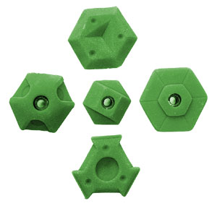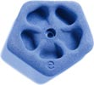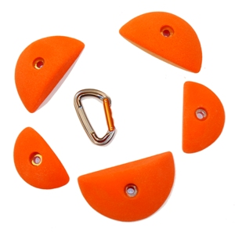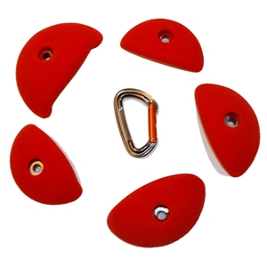
System Feet System Flower Pure Power Edges I Pure Power Edges II

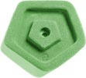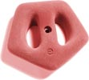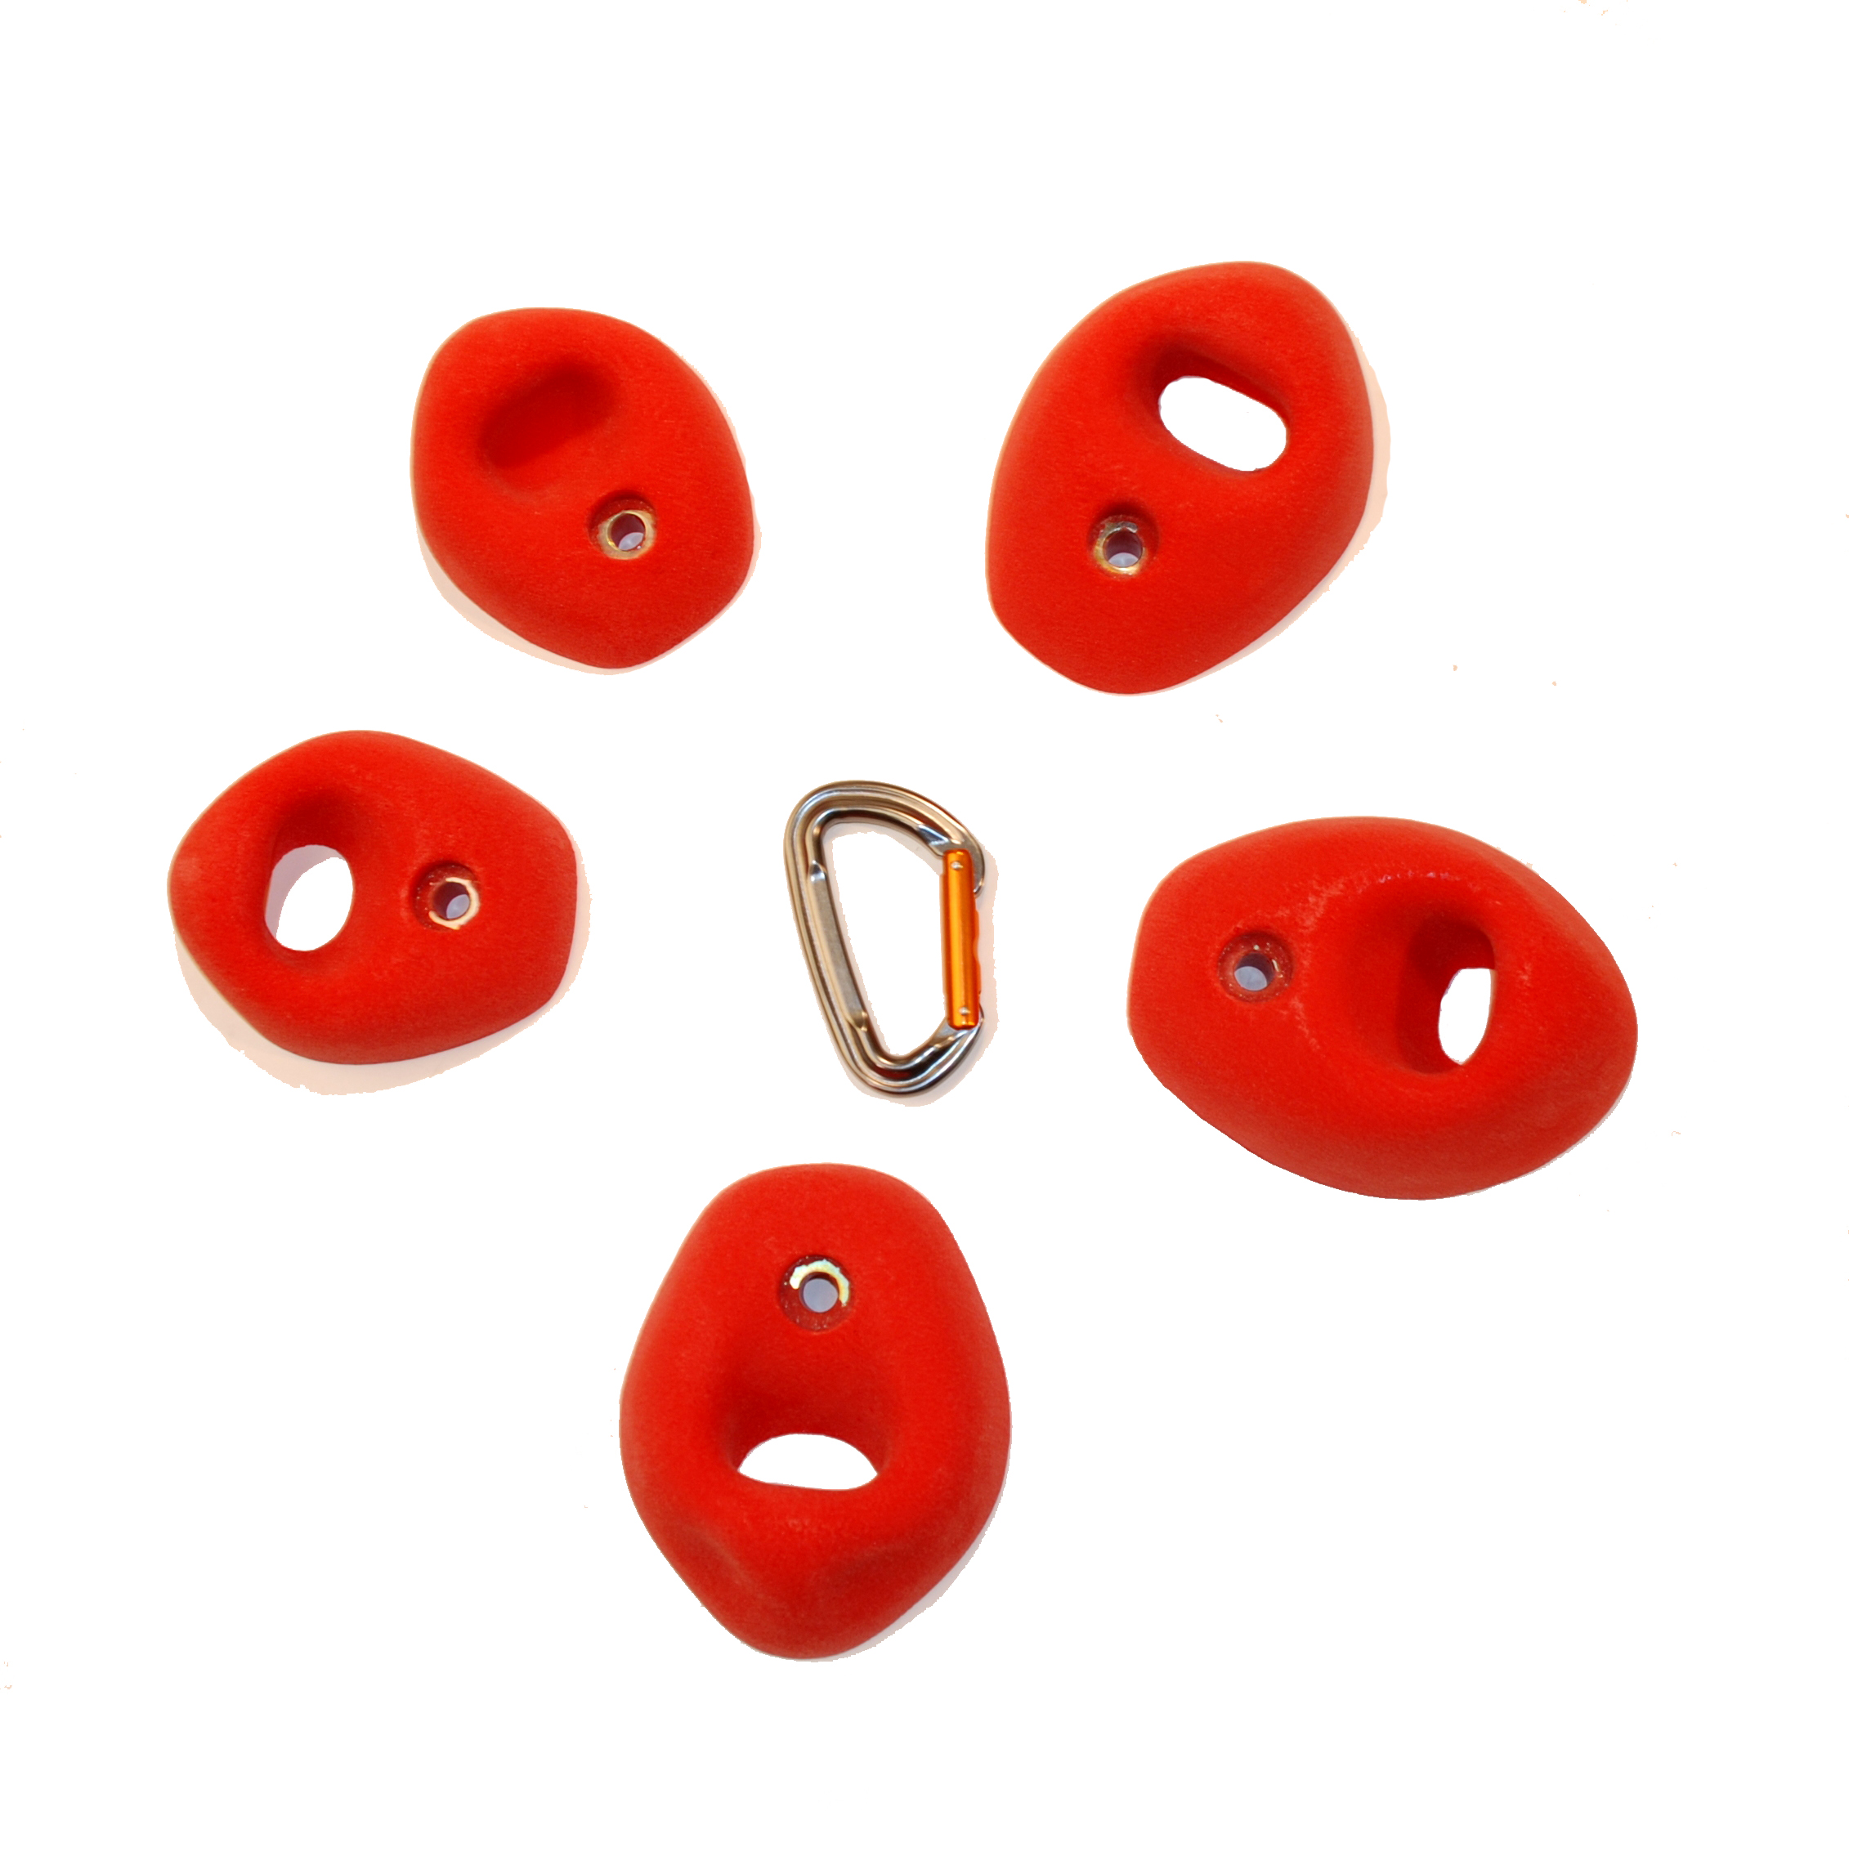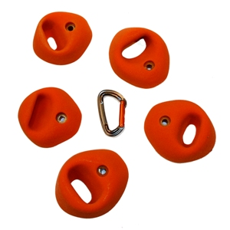
System Crimp System Large Pure Power Pockets I Pure Power Pockets II

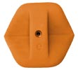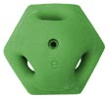
(Note for Melinda: Please delete existing picture of system wall and artistic character shown on the current Training page, for now.)

System Jug System Sloper/Pocket
INDIVIDUAL HOLD SET DESCRIPTIONS:

ARTISTIC SETS:

(10A5) Zen SP Slopers: There are varying degrees of depth and diameter in the raked line carvings, but each is a little sculpted masterpiece. These low profile sand piles will build up the calluses on your tips, centimeter by centimeter. 10 – M. ($48)
(10A6) Jibber Jabber Super Jugs: Might just be the most positive incut roof jugs on the market. Defined by the curled incut grab at the lip of each hold, these shapes might just make you feel stronger than you even are. Get them with the original set of Jibber Jabbers. 5 – XL. ($101)
(11A1) 2Tex Bubble Wrap Crimps: Our friend Kynan Waggoner had long had the idea for applying the 2Tex to Bubble Wrap shapes and it was first specifically introduced in his Signature set 2Tex Bubble Wrap Edges. These ten shapes are more intentionally competition grips – directional, low profile, hard-to-hold crimps. 10 – M. ($72)
LIMESTONE SETS:

(10L3) Limestone Rails: Like it's cousin sets the Limetone Semi-Huecos and Limestone Quatro Incuts, the rails have a natural rock aesthetic, and subtle finger divots and thumb grabs carved in. We had heard the masses calling for match-able edge rails and when we hear your calls, we deliver. 5 – L. ($63)
(10L4) Quarry Pinches: Like rectangular blocks blown out of a quarry, with smooth edges for the grabs, and limestone patina sculpted in the middle of each shape. All five grips are nearly a foot long, and easily matchable. Excellent for dynamic power climbing, steep tension, or toe-hand matches. 5 – XL. ($82)
(11L1) Myrocan Sloper Edges: The Ty Foose limestone ripple designs represented in the original Myorcan Tufas and in 2010 brought to the Myorcan Slopers have been copied by many but cannot truly be replicated. These ten shapes continue the brilliant theme. 10 – M. ($72)

(9L12) Lunar Eclipses: A continuation of the moon scoop theme, but with an added level of detail and variation. Crimp and edge finger rails - each grab with a bit different attitude. Don’t look directly at the sun kids. 5 – L. ($48)
SANDSTONE SETS:

(11S1) Horse Pens Moderates: Sculpted with subtlety, these intricate slopers make for great technical routes on slight overhangs, or work equally well for hard dynamic and powerful sequences on steeper walls. Pair them up with the already classic Horse Pens Giants to get the full southern sandstone feel. 5 – L. ($68)
(11S2) Mo Joe’s Slopers: Lying low for years in the hallowed ground of CATS, were a couple simple yet elegant sandstone slopers from an earlier generation of shaping. Chris Danielson introduces his first set here, with a set based on those classics. 5 – L. ($72)
(11S3) Caterpillar Finger Buckets: From the first set, Caterpillar Edges, a new theme was created. These positive finger bucket shapes continue the caterpillar style with friendly two-pad protruding grabs from a smooth and simple base. 5 – M. ($48)
(11S4) Caterpillar Shallows: Methodical. Calculated. Deliberate. All characteristics you should employ when routesetting with these smartly sculpted shapes. Excellent for competitions, with similarly low profile footprints on each shape, but with distinctly different grabs. 5 – M. ($48)
GRANITE SETS:
(10G2) Remarkable Rocks Mini-Jugs: One of the most popular new themes, the Remarkable Rocks Jugs now have a little brother set. The Mini-Jugs are still very positive shapes, but have a small footprint – great incut grabs for walls with limited space options. 5 – L. ($63)
(11G1) Peabody Flake Jugs: A rarity in the world of climbing holds, protruding flake jugs that are still very friendly to grab. 5 – L. ($77)
(11G2) Real Hueco Directionals: Any routesetter knows how important it can be to have “directional” shapes, best usable pulling in one orientation, and leaving few options for feet from above – these are likely to become classics in real-rock designed shapes. Set them up on a slight overhang with the Real Hueco Pinch Jugs or Real Hueco Incuts to build out the theme. 5 – L. ($48)
(11G3) Remarkable Rocks Pinches: Ryan Spence delivers – shaping one of the most versatile sets in the e-Grips line. Each of the five intricately sculpted shapes will seem like a completely new grip when rotated 90 degrees. 5 – L. ($68)
PURE SETS:
(11P1) Median Loaves: These long and narrow pinch grips with the simple pure line aesthetic complement the original wider hand size Loaves and the more modest Demi-Loaves. 5 – L. ($68)
FEATURE SETS:
(11U1) Bubble Wrap Beehive: It was a concept for years and now it’s a reality. A perfectly rounded egg-shaped sloper with the bubble wrap texture, and a devious subtle smoothed out scoop. Best for low angle climbing, and requires a modicum of contact strength. 1 – XXXL. ($82)
TRAINING SETS:
(10T1) Pure Power Edges I: The Edges I set has 5 flat grips with varying degrees of incut and finger pad depth. 2 of the shapes are full pad edges, flat, and slightly incut, and the other three are three pad grips, sloping, horizontal, and incut. 5 – L. ($48)
(10T2) Pure Power Edges II: Edges II each have a positive incut grip, with a very friendly rounded radius. 2 of the shapes are smaller two pad incuts and the other three have three pad variations, from positive incut to sloping pinch. 5 – L. ($48)
(10T3) Pure Power Pockets I: Pockets I has 5 two-finger grabs ranging from shallow one-pad to positive incut three-pad. Perfect for training pocket strength or forcing moves while routesetting. 5 – L. ($48)
(10T4) Pure Power Pockets II: The Pockets II is the more positive of the pocket training sets. Each grab is three or four fingers wide, and three of the five shapes are very incut, suitable as jugs on a 45 degree wall. The other two shapes are more shallow but still positive and incut. 5 – L. ($48)

